Introduction to vector

Put many values under a variable.

1. C function (2) Sequential (3)Replicate

“C” function: Concatenate

1. Numeric: x<-c(3,6,8)

2. Character: x<-c("morich","peyaj","alo")

3. Logical: x<-c(T,F,T)

Sequential Function:

Y<-1:10

Seq(1,10,2)

Replicated Function:

Rep(1,10)

Rep(1:3,4)

X<-c(4,5,7)

Rep(x,5)

Rep(x,1:3)

Rep(1:2,c(10,10))

Rep(1:2,each=10)

Find a length f below vector?

A<-c(2,4,6,7,8)

Length(A)

Include 10,11 in A and Store it in x

X<-c(A,10,11)

Remove first value

X[=1]

Position of a value

X[3]

Find First ,second, Third

X[1:3]

Find 1st, 4th

X[c(1,4)]

Replace 1st element 19

X[1]<-19

Replace 2nd value by x^2+1

X[2]<-x[2]^2 +1

Replace 1st three value by 8

X[1:3]<-8

Replace 3rd , 4th by 99,34

X[3:4]<-c(99,34)

Replace 10 to 15 element by 20 to 30 increament by 2

X[10:15]<-seq(20,30,2)

Replace 2,4,6 by 67,89,65

X[c(2,4,6)]<-c(67,89,65)

Replace by 35 where all values of x greater than 5

X[x>5]<-35

Show last 9 values?

N<=length(x)

M<= x[(n-8):n]

Find total,average,median,standard deviation, log(x)

Sum(x)

Mean(x

Mean division= (summation |xi-mean of x|)/n

Md<-sum(abs(x-mean(x)))/length(x)

Find skewness, kurtosis and co-efficient of variation

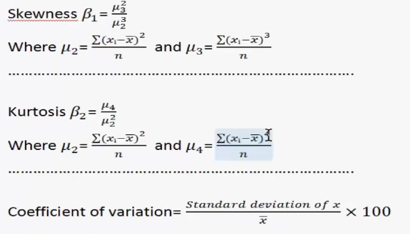

N<-length(x)

Mu2<- sum( (x-mean(x))^2)/N

Mu3<- sum( (x-mean(x))^3)/N

Mu4<- sum( (x-mean(x))^4)/N

Beta1<- Mu3^2/Mu2^3

Beta2<- Mu4/Mu2^2

Cv<-(sd(x)/mean(x))*100

Create a vector using 1,2,……10,10,10,10,11,13,………99,100,101,102,…..109

Z<- c(1:10,rep(10,3),seq(11,99,2,100:109)

First 20 element of z assign x1 and next 20 value x2

Draw a random sample of size 100 with mean 10 variance 20 and round it 3 decimal

S<-rnorm(100,10,20)

Round<-round( s,3)

How to plot

#make a suitable plot indication legend and ttle

W<-sort(rnorm(20)); y1<-sort(rnorm(20));y2<-sort(rnorm(20))

Plot(w,y1)

Plot(w,y1,type=”1”,xlab=”x values”, yalab=” y values”)

Plot(w,y1,type=”1”,xlab=”x values”, yalab=” y values”,main=”Grap Tile”)

w<-sort(rnorm(20))

y1<-sort(rnorm(20))

y2<-sort(rnorm(20))

plot(w,y1)

lines(w,y1,lty=2,col="blue")

lines(w,y2,lty=2,col="red")

legend(-1.5,1.5,c("y1","y2"),lty=c(1,2),col=c("black","blue")

#using w and y1 draw a multiple ploat on the same page

par(mfrow=c(2,2))

plot(w,y1)

plot(w,y2)

plot(y2,y1)

plot(w,y1)

Introduction to matrix

1. Using dimension

x<-1:12

dim(x)<-c(3,4)

x

A=array(1:12,dim=c(3,4))

A

1. Using matrix function

A=matrix(1:12,nrow=3,ncol=4)

A

A=matrix(1:12, 3,4)

A

A=matrix(1:12,nrow=3,ncol=4,byrow=T)

A

1. Using rbind and cbind function

x1<-1:4

x2<-5:8

x3<-9:12

rbind(x1,x2,x3)

1. Diagonal matrix

x<-1:5

diag(x)

# identity matrix

diag(rep(1,5))

A=matrix(1:12, 3,4)

A[1,]

A=matrix(1:12, 3,4)

plot(A[,1],A[,2],type="1"

y4<-apply(y,1,sum)

cbind(y,y4

Dataframe

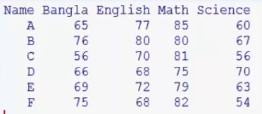

Name<-c("A","B","C","D","E")

Bangla<-c(65,76,56,66,69)

English<-c(77,80,70,68,68)

Math<-c(80,85,75,69,68)

Science<-c(80,85,75,72,68)

Result<-data.frame(Name,Bangla,English,Math,Science)

Result

Name<-c("A","B","C","D","E")

Bangla<-c(65,76,56,66,69)

English<-c(77,80,70,68,68)

Math<-c(80,85,75,69,68)

Science<-c(80,85,75,72,68)

Result<-data.frame(Name,Bangla,English,Math,Science)

fix(Result)

summary(Result)

mean(Result$Math)

Result$Math

min(Result$Math)

summary(Result$Math)

Change directory and Import data

data<-read.table("problm.txt",header=T)

getwd()

setwd("C:/Users/Salah")

read.csv(“”)

#data read from spss

Library(foreign)

Read.spss(“gg.sav”,to.data.frame=T)